Summary: All of the old features worked as intended with the values unchanged. During the time trials it seems that the time was improved over the previous version when there was a smaller number (or %) of labeled cells and an set back when there were lots of labeled cells. I did not get a chance to test it against the old version on the web because none of my browsers will bring up the MIRDcell applet: firefox crashes on the page and chrome and edge wont even open the applet.

Time benchmarking (average of 3 tests)

1. 210Po, RC = 5 µm, sphere 100 µm radius, 100% labeling, 4169 cells,

t = 9.8s (from 35s)

1. 210Po, RC = 5 µm, sphere 200 µm radius, 100% labeling, 33401 cells,

t = 2:40 (from 1:30)

1. 210Po, RC = 5 µm, sphere 200 µm radius, 1% labeling, 33401 cells,

t = 15s (from 50s)

1. 131I (avg β), RC = 5 µm, sphere 200 µm radius, 1% labeling, 33401 cells,

t = 35s (from 1:40)

1. 131I (full β), RC = 5 µm, sphere 200 µm radius, 100% labeling, 33401 cells,

t = 2:42 (from 1:01)

1. will do the 30-50 minute tests later

Worked Examples: Comparison between my results and those run previously

1. Cells in Suspension

Old new

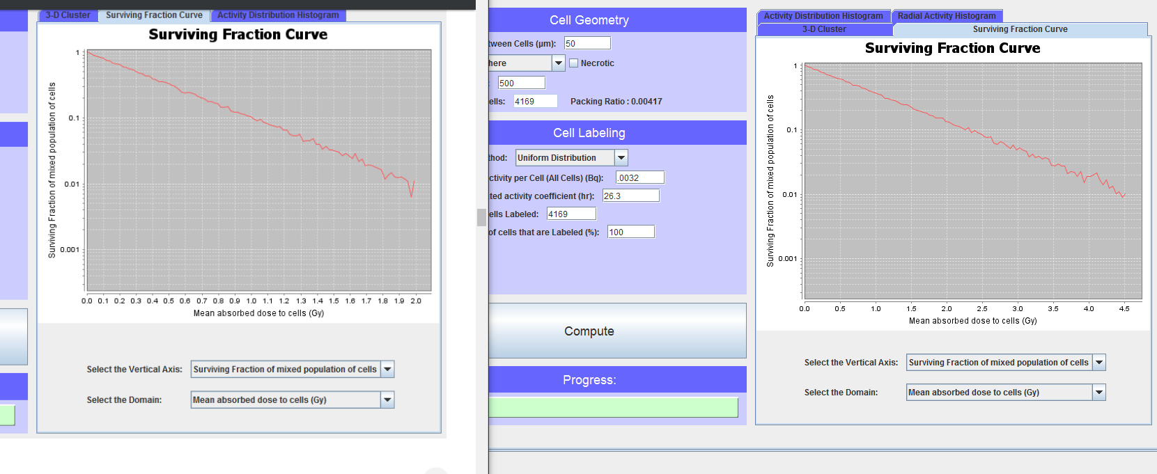

2. 3D Multicellular Cluster of Cultured Cells

old new

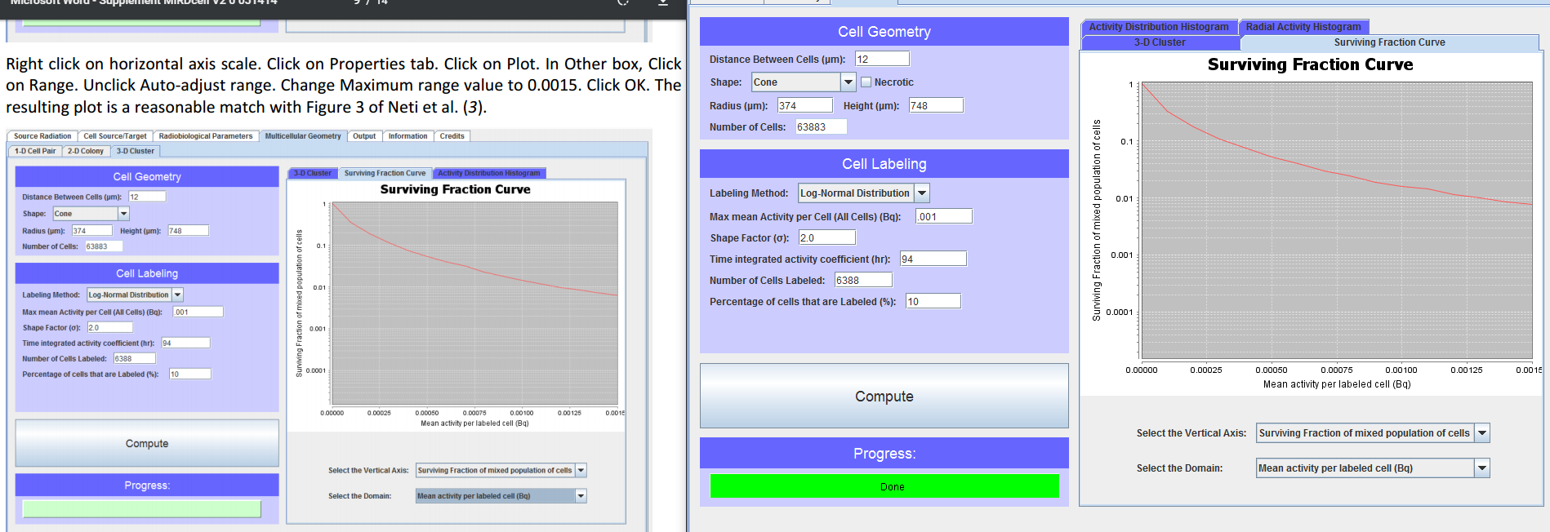

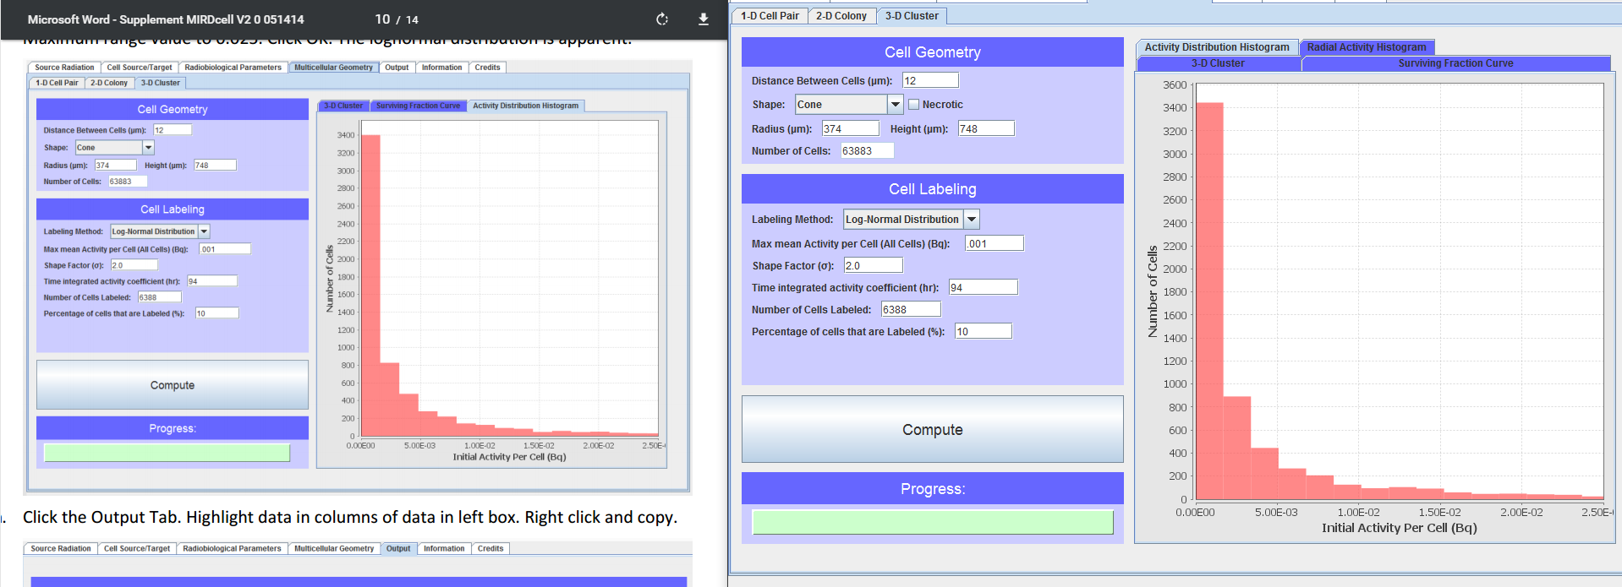

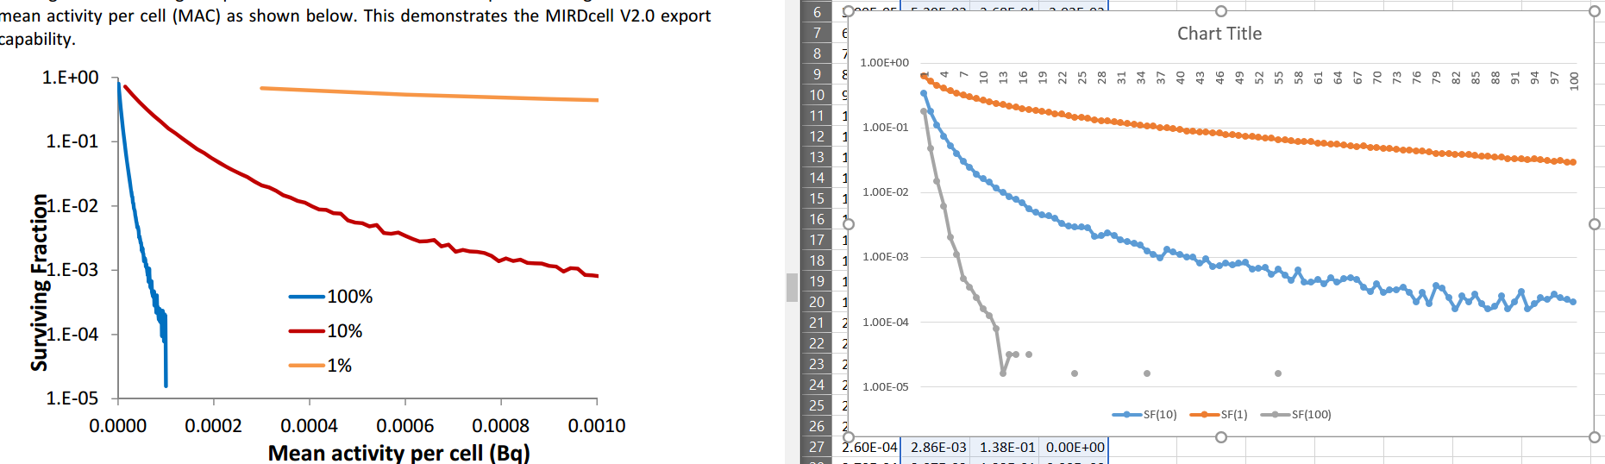

3. 3D Multicellular Clusters In Vivo. Analyses involving decay chains:   211At

Old new

